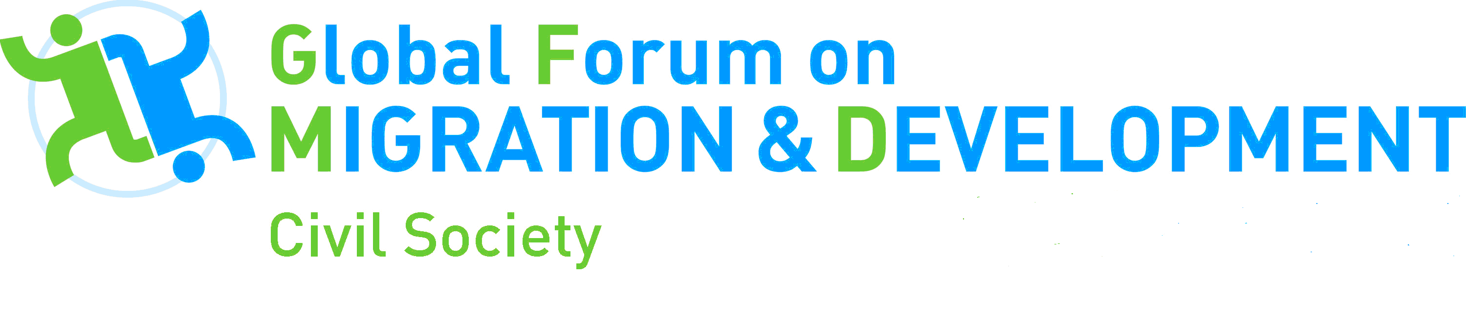
Third draft: Common Space, Berlin Friday 30 June 2017
15 March 2017

Title: Mechanics for Safe, Orderly and Regular Migration

Format
The Opening of Common Space will feature framing from the GFMD Co-chairs and Civil Society Chair, Davos-style, together with a keynote from the SRSG, and a brief explanation of the Common Space programme.

Three breakout sessions followed by seven smaller focus sessions will then treat major aspects of the Global Compact for Safe, Orderly and Regular Migration.The breakout sessions will introduce and explore possible common understandings of “safe, orderly and regular”; focus sessions will go deeper to discuss concrete mechanisms of implementation in seven specific areas.

Each one-hour breakout session will begin with the moderator introducing the theme and the four discussion starters, who will frame the issue. Two of the discussions starters will be states, two from civil society, or exceptionally other non-state actors as appropriate. One of the civil society discussion starters will be a rapporteur from the Civil Society Days, presenting key conclusions and recommendations on the theme from deliberations in the Civil Society programme of the GFMD. Inspired by guiding questions shared in advance, each discussion starter will speak for 5 minutes. The moderator will then open the floor for interaction, alternating as possible between state and civil society participants from the floor.

Each of the three breakouts will have a rapporteur who will record key points and recommendations of the session. Highlights of the three breakouts will be presented in one consolidated report back to the Common Space Wrap-up plenary.

After a coffee break, 7 smaller, two-hour focus sessions will explore and discuss concrete mechanisms through which safe, orderly and regular migration can be brought about, and make recommendations. Each focus session will have a moderator, a maximum of three discussion starters (including at least one each from states and civil society) and a “mechanism-tracker” whose task is to record and report such discussion and recommendations, to be consolidated with highlights from the other focus sessions for reporting back in the Common Space Wrap-up plenary. Discussion in each focus session will be inspired by a set of three guiding questions shared in advance. Participants are free to proceed to the focus session of their choice.

Following lunch, Common Space will wrap-up with a one-hour plenary for consolidated reports-back from the breakout and focus sessions, and a closing ceremony.

Note that a set of “by invitation” small, interactive Tea tables will follow after Common Space in the same venue.
- turn page for programme

7h30 – 9h00 | Participants arrive
9h00 – 9h45 | Opening Plenary  Opening of the GFMD Common Space, by the German and Moroccan Co-Chairs and Civil Society Chair  Keynote speaker: SRSG  Introduce methodology for the sessions  Plenary in Weltsaal (500) with simulcast in the Europasaal (200)
09h45 – 11h00 | Breakout A  Safe migration  Weltsaal  (380 participants) |  |  | Breakout B  Orderly and Regular  Migration  where work is the driver  Europasaal  (200 participants) |  |  | Breakout C  Orderly and Regular Migration  where work is not the principal driver  Library  (120 participants)
11h00 –11h30 | Coffee break + move to focus session
11h30 –13h30 | Focus session 1  The meaning and mechanisms of safety for children on the move  Ministersaal 1  (40-50 participants) | Focus session 2  The meaning and mechanisms of safety for other migrants in vulnerable situations  Europasaal  (200 participants) | Focus session 3  The meaning and mechanisms of safety for migrants and societies in the face of growing xenophobia  Ministersaal 2  (40-50 participants) |  | Focus session 4  The meaning and mechanisms of safety in contexts of return and reintegration  Weltsaal  (180 – 220 participants) | Focus session 5  Mechanisms for Labour Mobility and regularization  Library  (120 participants) | Focus session 6  Mechanisms for Ethical Recruitment of Migrant workers  Ministersaal 3 (40-50 participants) | Focus session 7  Mechanisms for complementary pathways for refugees and migrants, including family reunification  Ministersaal 4  (40-50 participants)
13h30 – 14h45 | Lunch
14h45 – 15h30 | Common Space Wrap-Up  Reports back: One consolidated report from breakouts, and consolidated report(s) from focus sessions, final remarks by Civil Society Chair  Plenary in Weltsaal (500) with simulcast in the Europasaal (200)
15h30-  16h00 | Closing Ceremony, by the German and Moroccan Co-Chairs and SRSG  Plenary in Weltsaal (500) with simulcast in the Europasaal (200)
16h00-16h30 | Participants leave
16h30- 18h00 | Teatables (by invitation)  Ministersaal 1-4 and lounge to the right of the Weltsaal

