GLOBAL ASSISTANCE PROGRAMME FOR

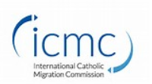
Membership Number: 22AYCA080792
Your International Assistance Centres  - Dubai: +971 4 601 8777  - London: +44 (0) 208 762 8008  - Paris: +33 (0)155 633 155  - Philadelphia: +1 215 942 8226  - Singapore: +65 6338 7800  - Sydney: +61 2 9372 2468 | Call International SOS 24/7  Be ready to provide:  - Your family name and first name  - International SOS membership number  - Name of the company and /or name of the subsidiary you work for  - Phone number where you can be reached  - Reason of your call
As a member of International SOS, you have access to our global network of 27 Assistance Centres. This assistance programme will provide expanded protection to deal with travel, medical and security needs that might arise anywhere across global markets. Our doctors, security experts and assistance coordinators are available 24/7 to provide advice in your language, and to support you in case of emergency. This service is included in your membership.

We PREPARE you… before you travel
Medical Information  - On-call: vaccinations, medical information, etc.  - Online: illness, hygiene, quality and level of local healthcare, precautions to take, access to healthcare, primary care, etc. | Security information  - On-call: transportation, accommodation, areas to avoid, recommended behavior, advice on a situation, etc.  - Online: information on countries and large cities, level and types of risks, local customs, practical (telecommunications, currency, etc.) and political aspects, etc.
We TAKE CARE of you… whilst abroad
Medical Support  - On-call advice: medical and emergency advice,  Referral to doctors and specialists as well as coordination of treatment with the treating practitioner  - Access to International SOS clinics depending on your membership level  - Guaranteed payment of medical expenses provided for in your health insurance contract  - Email alert in the event of a health risk in a country | Security Support  - On-call advice: security information and emergency advice  - Assistance in the event a passport or other official document is lost or stolen  Referral to vetted security service providers  - Email alert in the event a situation develops or deteriorates
We ASSIST YOU… in the event of a medical or security emergency
Medical Assistance  - Emergency medical evacuation/repatriation  - Compassionate visit and family travel assistance  - Transportation in the event of death, assistance with legal formalities  - Hospital follow-up, control of healthcare expenses | Security Assistance  - Recommendations in the event of an emergency or critical event  - Organisation of the evacuation and repatriation by our teams of in-field experts, through to the final destination

EXAMPLES OF HOW TO USE YOUR ASSISTANCE PROGRAMME
When you are on a business trip, International SOS doctors, security experts and assistance coordinators
are available 24/7 to:

We PREPARE YOU… before you travel

Find out all you can about the city and country you are travelling to including medical recommendations and safety advice, required vaccinations, etc.

- What medication do you take with you? Are there any customs restrictions?
- Your flight arrives at night in a city considered ‘dangerous’. What do you do?
We TAKE CARE of you... while abroad

Contact us for medical advice, to be referred to a doctor or a specialist, to obtain the advice of a security expert or for up-to-date travel information, etc.

- You have a dental problem and want to consult a dentist who speaks your language
- You have learnt through the local media that there are incidents of civil unrest and you want to know how to react

We ASSIST YOU… in the event of a medical or security emergency

Whether you require a hospitalisation, evacuation or repatriation for health or security reasons, assistance is available to you at any time.

- You have been hospitalised for medical emergency and you want to know how to manage your medical expenses
- You have just heard an explosion outside your hotel. What do you do?

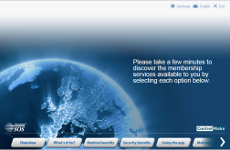
Watch the International SOS Membership eGuide
- How to mitigate travel risks ahead of time
- Real life scenarios on the type of advice you would receive
- What are the 24/7 medical and travel security services available to you
- How to download the International SOS Assistance App
- https://www.internationalsos.com/elearning/comprehensive/

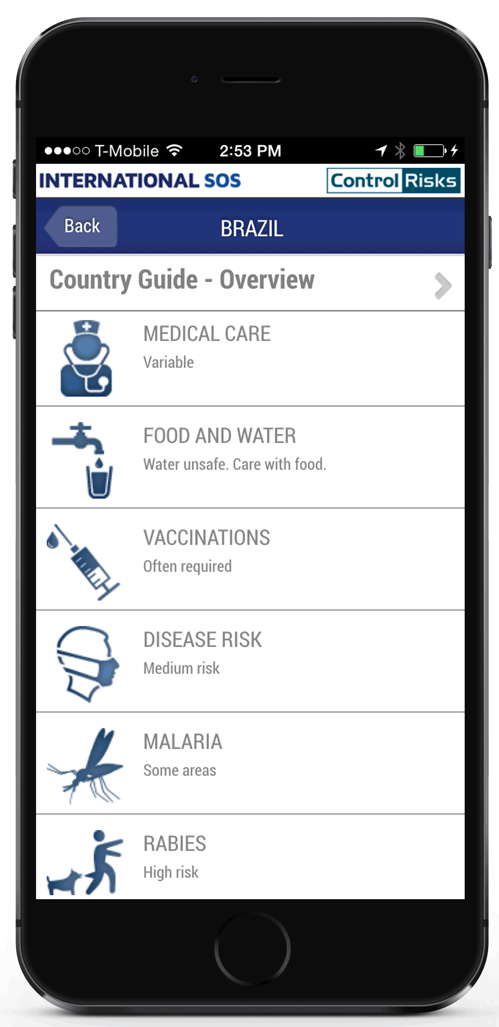
Download the International SOS Assistance App on your smartphone
Use the International SOS Assistance App before and during your next trip for:
- Easy access to your local Assistance Centre, in an emergency and for everyday advice
- Expert medical, security and travel assistance
- Receive the latest information about your destination
- https://www.youtube.com/watch?v=pIrapsSV8Ss

app.internationalsos.com
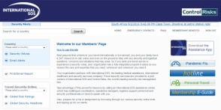
Connect to the International SOS Information Portal
Access detailed information on more than 200 countries and 300 cities:
- Evaluation and analysis of health, travel and security risks
- Daily updates on travel security, disruptive incidents and situational developments
- Travel guides and cultural tips
- Subscription to proactive email alerts

internationalsos.com

